**Sequence Diagram - Share Status**

Entity classes: User

Boundary classes: StatusView

Control classes: StatusController

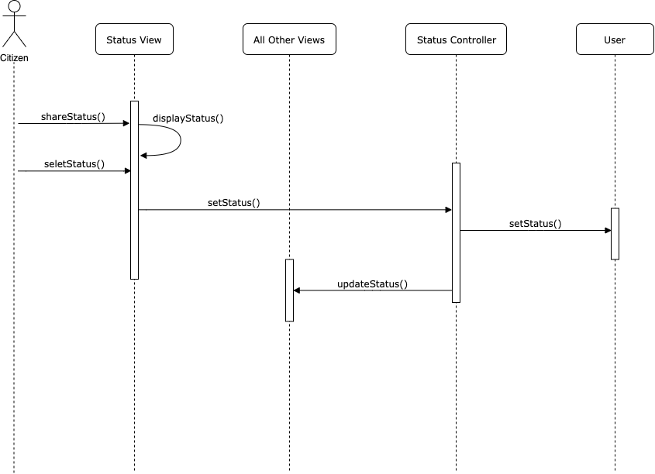

**Class Diagram - Share Status**

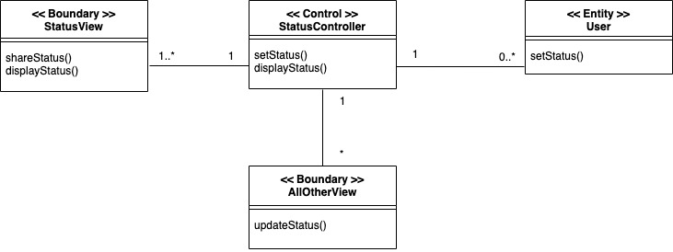

**Mapping between UML Diagram and Code Structure**

|  |  |  |
| --- | --- | --- |
| Analysis Class Type | Analysis Class | Corresponding Code Element |
| Boundary | StatusView | frontend/page/chatroom.js |
| Control | StatusController | backend/controllers/status.js |
| Entity | User | backend/models/User.ts |